Notes from EcoSeminar

Google doc: <https://docs.google.com/document/d/1RGRQ0GJIrEvwiPdS3nzJTx8GjN5XhI0w-pyGW5w7YYc/edit>

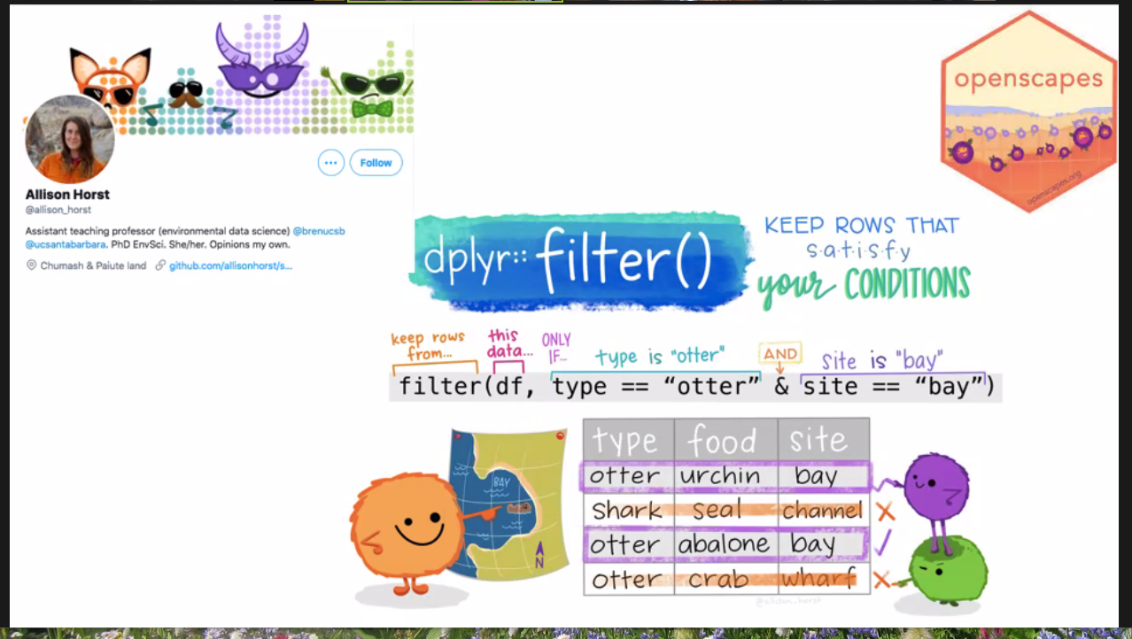



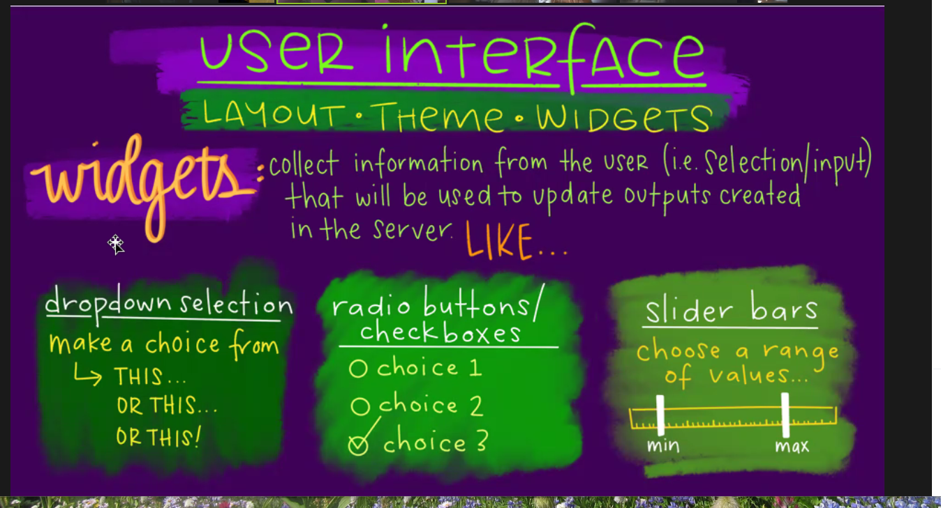

More widgets in the google doc: <https://docs.google.com/document/d/1RGRQ0GJIrEvwiPdS3nzJTx8GjN5XhI0w-pyGW5w7YYc/edit>

